**Name :** Aggelos Konioris

**Batch code :** LISUM02

**Submission date :** 14/8/2021

**Submitted to :** Data Glacier

Short summary of our analysis

* Find the dataset of NBA players from the Kaggle source
* Use Python programming language to import the dataset and start the analysis
* Prepare the dataset using the suitable algorithms
* Utilize linear regression to predict the salary of an NBA player
* Save the model to our disk as pickle file and the load it to create the web application using Flask
* Write code on python for the web app
* Write HTML code on Notepad++ to complete our deployment on flask
* Use Anaconda prompt to run the python app and then attach the link with the http that is created to our browser to see our web app

Importing and organizing the dataset

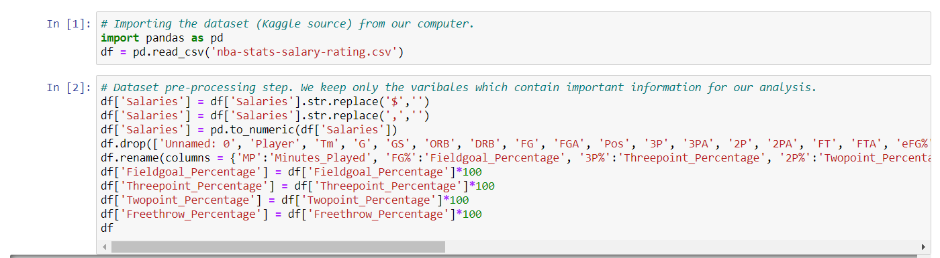

Splitting the dataset into train and test dataset then perform linear regression model and save the model to the disk

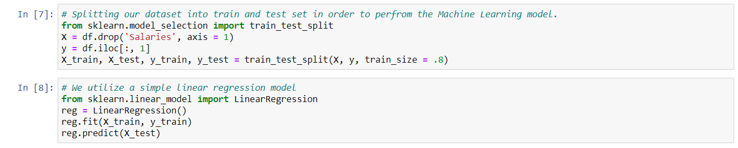

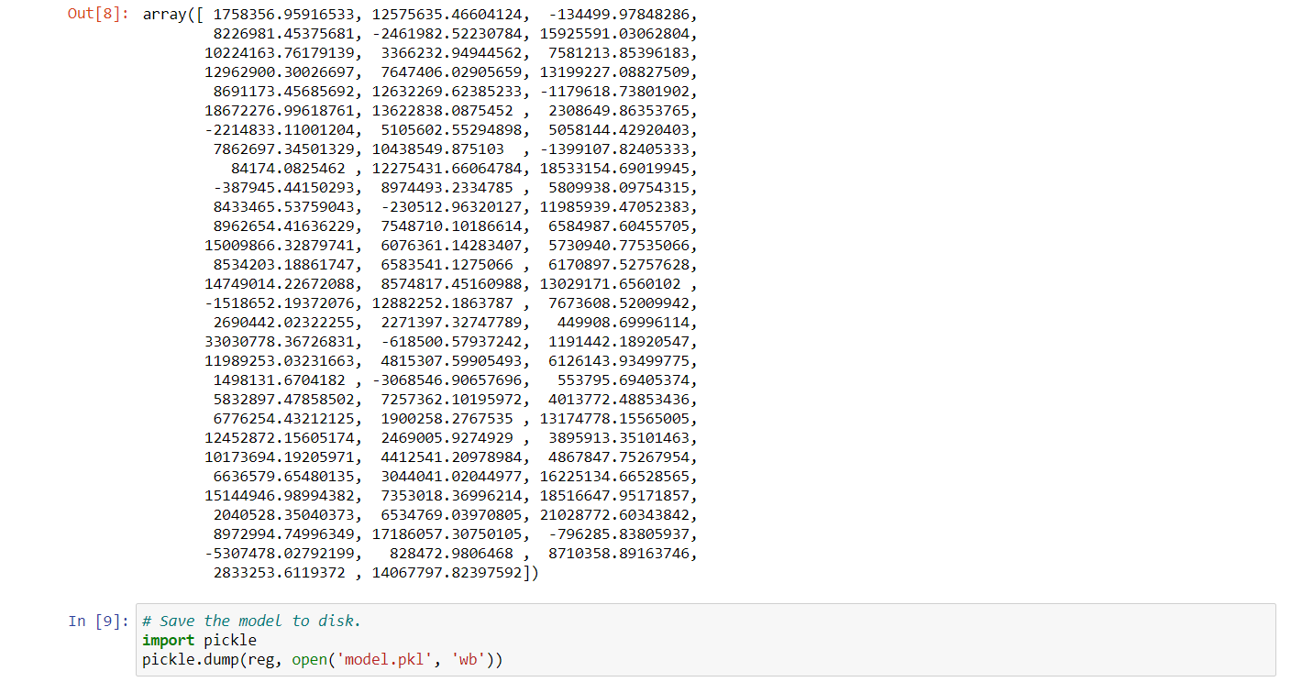

Using Flask to write code for the deployment

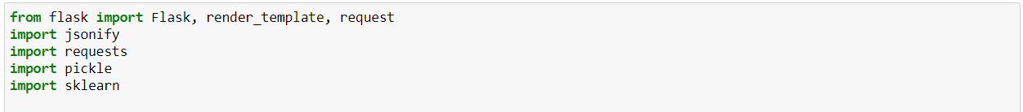

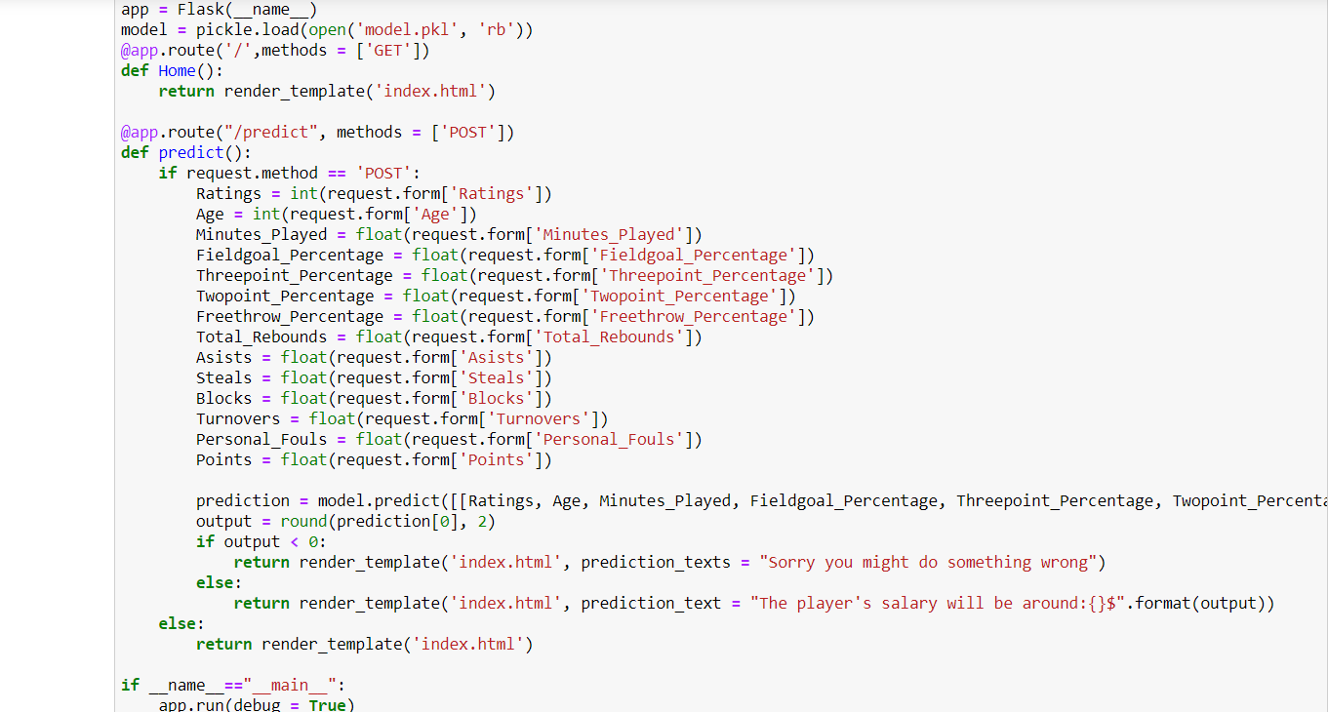

HTML code for the web application

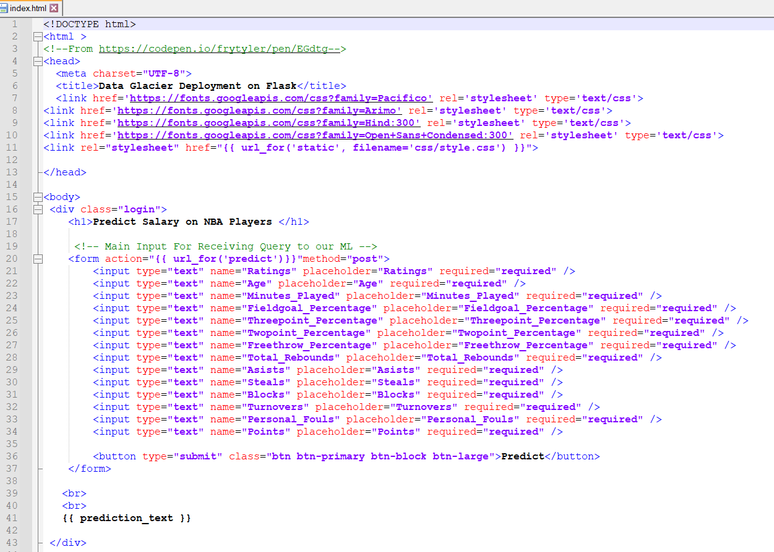

Anaconda prompt with the http

